Experiment 2
Determination and plotting of Electric field (E) and Electric flux density (D) in a sphere full of charges with varying radius

Code File Name: Exp2_EF_FD.m
Code
clc;
clear;
q=input('Enter the value of q=');
r=input('Enter the value of r=');
epsilon=8.854e-12;
k=1/(4*pi*epsilon);
E=k*q/(r^2);
disp("The electric field is");
disp(E);
D=epsilon*E;
disp("The flux density is");
disp(D);
% Plot
x=linspace(0.1,10,50);
E_plot=k*q./(x.^2);
D_plot=epsilon*E_plot;
figure;
subplot(1,2,1);
plot(x,E_plot);
xlabel('Radius');
ylabel('Electric field');
subplot(1,2,2);
plot(x,D_plot);
xlabel('Radius');
ylabel('Flux density')
Command Prompt
Enter the value of q=2*10^2
Enter the value of r=0.1*10^-3
The electric field is
1.7975e+20
The flux density is
1.5915e+09
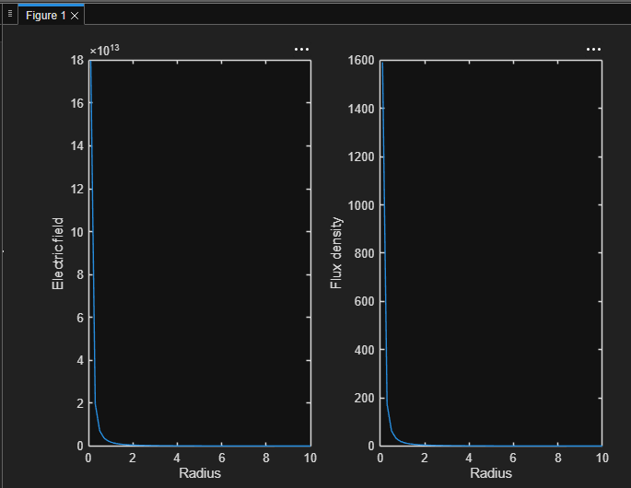
Output Graph

